**Part A**

(To be referred by students)

The project life cycle is a 4-step framework designed to help project managers guide their projects successfully from start to finish. The purpose of the project life cycle is to create an easy to follow framework to guide projects.

**What are the 4 stages of the project life cycle?**

* [**The project initiation stage:**](https://venngage.com/blog/project-life-cycle/#1) understand the goals, priorities, deadlines, and risks of the project
* [**The project planning stage:**](https://venngage.com/blog/project-life-cycle/#2) outline the tasks and timeline required to execute on the project
* [**The project execution stage:**](https://venngage.com/blog/project-life-cycle/#3) turn your plan into action and monitor project performance
* [**The project closure stage:**](https://venngage.com/blog/project-life-cycle/#4) analyze results, summarize key learnings, and plan next steps

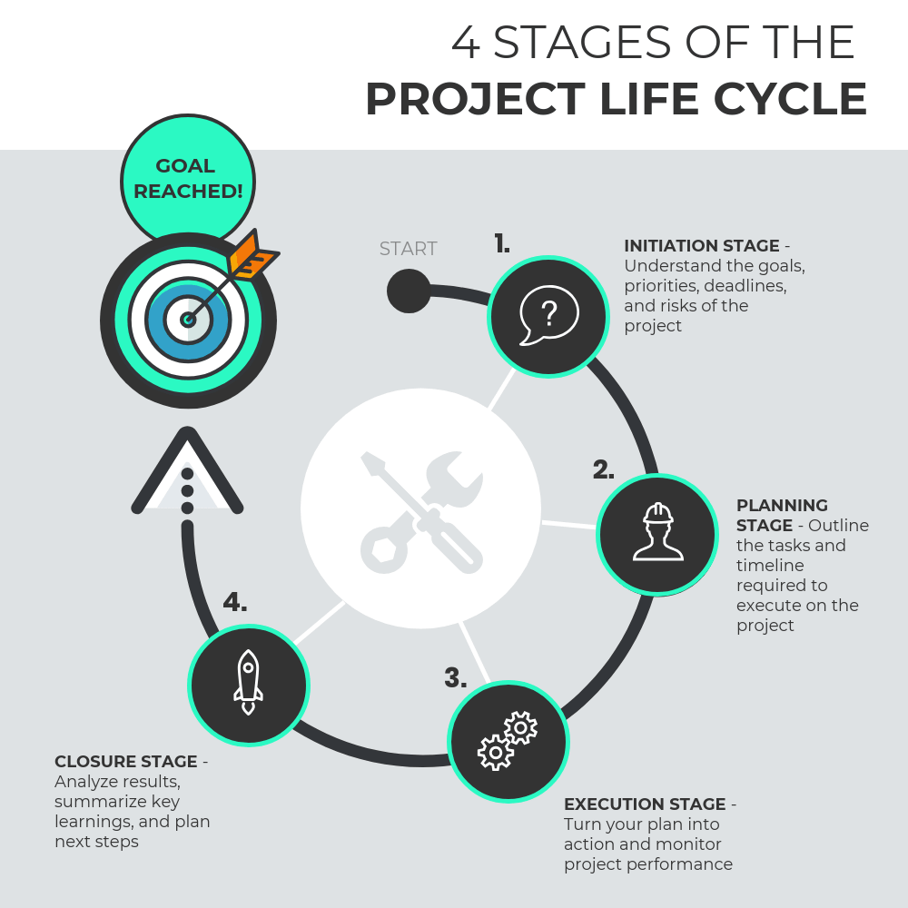

Ref: [The 4 Project Life Cycle Phases (With Templates For Each Stage) - Venngage](https://venngage.com/blog/project-life-cycle/)

**Part B**

(To be completed by students)

Build a Project life cycle for your project topic

### The Project Initiation Stage:

* Formulate the idea for the Ed-Tech startup
* Define the project scope
* Identify key stakeholders
* Obtain approval to proceed

### The Project Planning Stage:

* Plan the project in detail
* Define project goals and objectives
* Identify tasks and dependencies
* Define roles and responsibilities for the project team

### The Project Execution Stage:

* Develop and test the Ed-Tech platform
* Integrate and test any third-party tools or services
* Prepare user documentation
* Finalize the platform for launch

### The Project Closure Stage:

* Evaluate project success
* Archive project documentation
* Obtain final sign-off from stakeholders
* Celebrate project completion.

